CenterPoint Energy Triple Bottom Line Analysis Report

***Authors***

*Bhavana Lalam*

*Esteban Emanuel Salguero*

*Likitha Rayapati*

*Yuktha Tejaswi Baisetti*

**CONTENTS**

|  |  |
| --- | --- |
| **S.No** | **Name** |
| 1 | Executive Summary |
| 2 | Introduction |
| 3 | Financial & Operating Performance Analysis. |
| 4 | Environmental Stewardship & Sustainability Analysis. |
| 5 | Social Responsibility & Community Contribution Analysis. |
| 6 | Conclusion |
| 7 | Appendix |

**Executive Summary**

To understand CenterPoint Energy’s current position and where it can possibly be heading in the future, the triple bottom line approach has been to gauge its performance. The triple bottom line analyzes three distinct areas which they are the following, the company's financial & operating performance, its approach to environmental stewardship & sustainability, and lastly, its involvement in social responsibility & community contribution. Each of these areas are key components to determining a company’s overall status. In today’s age, stakeholders are attracted to businesses that perform well in each of these areas as they do not only touch on the company's finances but also their ethics as a company’s social image is held in high regard.

To gauge CenterPoint’s financial & operating performance, areas such as the company’s revenue, shareholders, and customers will be analyzed. These deal with where the company’s financial support is coming from and how it’s been making a profit over the past couple of years.

In monitoring CenterPoint’s environmental stewardship & sustainability, the company’s usage of harmful resources such as coal and the use of transmission lines from the past four years will be reviewed. Coal plays a major role in CenterPoint’s operations and ensuring a well-balanced approach in its usage can help the company limit the probability of causing major harm to the environment.

Lastly, to evaluate CenterPoint’s involvement in social responsibility & community contribution, the company’s employee-centric initiatives, and its contribution to charitable causes.

With the evaluation of these three areas, the current position of CenterPoint Energy and the areas in which are fine or are in need of improvement will be highlighted and therefore ready to be addressed.

**Introduction**

In today's competitive business environment, a company's success extends beyond just financial performance. Stakeholders increasingly value a commitment to environmental and social responsibility. This report, commissioned by CenterPoint Energy, utilizes the Triple Bottom Line framework to assess its sustainability. The Triple Bottom Line approach evaluates a company's performance across three critical dimensions: financial & operating performance, environmental stewardship & sustainability, and social responsibility & community contribution. Examining each of these pillars provides a comprehensive picture of CenterPoint Energy's current position and potential future trajectory. Understanding its sustainability performance will equip CenterPoint Energy with valuable insights to inform strategic decision-making and propel it toward long-term success.

**Data Sourcing and Wrangling:**

The foundation of our analysis lies in the systematic sourcing of data from CenterPoint Energy's meticulously maintained records. The raw data, a representation of the company's operations, underwent rigorous wrangling to ensure accuracy and relevance. Initial steps included the purification of datasets, where anomalies were corrected, and outliers assessed for validity. This was followed by a strategic restructuring where datasets were aligned chronologically, ensuring consistency across the evaluated time frame.

**Financial & Operating Performance Analysis**

In evaluating the Financial and Operating Performances of CenterPoint Energy, four main areas were used to determine the company’s performance. These areas are as follows, the company’s revenue by products and services, total customers, top shareholders, and the consolidated results of operations. When considering these areas, data was extracted from 2020 to 2023. This gives a gauge of how the company has recovered from the COVID-19 pandemic and where it is progressing towards.

When examining the revenue generated by CenterPoint’s products and services, from 2021 to 2023, CenterPoint itself has generated $26,398 million in revenue. The year that produced the most revenue was 2022 with $9,321 generated, and the year with the least was 2021 which generated $8,352 million. Among each year, the product/service that contributed the most to revenue was the retail gas sales. In 2022, retail gas sales were at their highest as it produced $4,759 million in revenue. In contrast, the product/service that contributed the least was gas transportation as it averaged about $11.25 million per year in revenue.

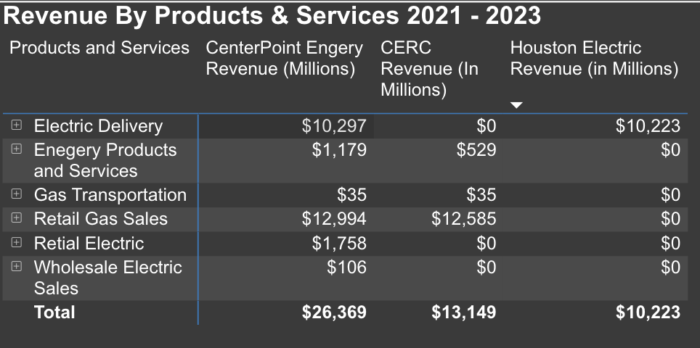

**Figure 1**

Another important metric analyzed was the number of customers CenterPoint Energy had yearly, specifically its Texan customers. From 2020, as we all know was the year of the pandemic, to 2023, CenterPoint had a steady increase in customers with a major jump of about 1.5 million between 2021 and 2022. So, the year with the least number of customers was 2020, with about 1.8 million, and the year with the highest happens to be 2023 with 2.8 million. Total customers can be split into two distinct groups commercial/industrial and residential customers, both of which follow a similar pattern of steady increases since 2020. Out of the two, Residential customers make up most of the market by a large margin. In 2023, residential customers made up about 90% of the total customers with a total of 2.5 million.

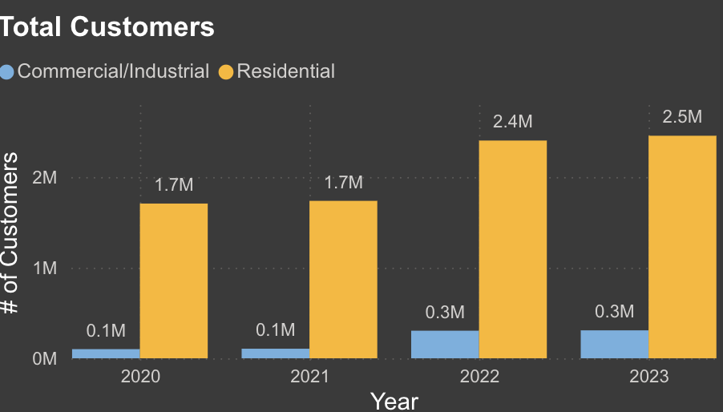

**Figure 2**

The next point of emphasis is to evaluate the company’s stock ownership. In 2023, the top three entities who hold the most shares are Capitol International Investors, The Vanguard Group, and BlackRock Inc. Capitol International Investors owns the most shares, owning 33.03% of all shares with a total of 81 million, which is a tremendous increase since they first entered back in 2021 with 29 million. The Vanguard Group owns 31.05% of all shares with a total of around 77 million, which is another substantial increase from 2020 in which they held about 60 million. BlackRock Inc. owns 21.17 % of all shares with a total of around 52 million. The top three shareholders have been consistent since the emergence of Capitol International investors in 2021 with The Vanguard Group being number one until 2023.

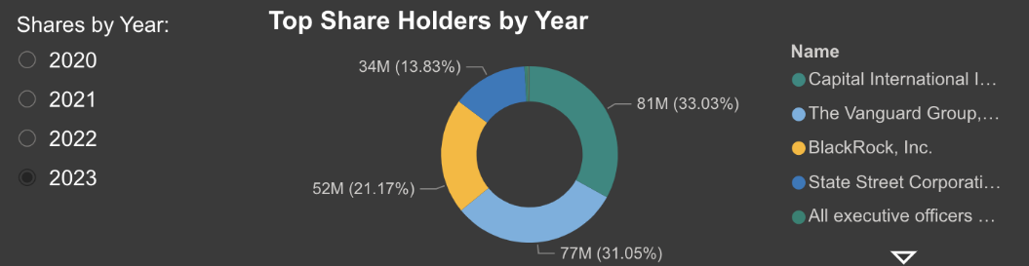

**Figure 3**

Lastly the Consolidated Results of Operation from 2021 to 2023. Here there are four main areas in which were evaluated, Corporate & Other, Discontinued Operations, Electric, and Natural Gas. For the most part, every department generated a positive margin throughout these three years except for the Corporate & Other. In total, from 2021 to 2023, the consolidated results of operation reported a positive value of $3,266 million. The year with the highest value was 2021 with a total of $1,391 million because of operations, with the lowest being 2023 with $867 million.

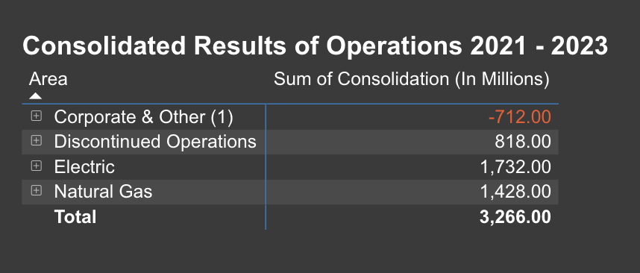

**Figure 4**

**Environmental Stewardship & Sustainability Analysis**

The company saw an increase in residues in 2021, likely due to energy production during that time. However, there was a decrease in 2022, suggesting a change in energy production methods or efficiencies. Throughout these years, CenterPoint Energy produced an amount of residues as a result of coal-based energy production, highlighting the need for an environmental management plan.

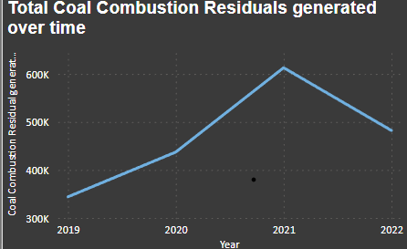

**Figure 1**

CenterPoint Energy showcased a recycling pinnacle in 2019, which subsequently declined in the following year, potentially indicating operational adjustments or external constraints. Notably, in 2022, there was a marked improvement in recycling efforts, suggesting effective measures taken by the company to enhance its recycling capabilities, thereby underscoring its dedication to environmental conservation.

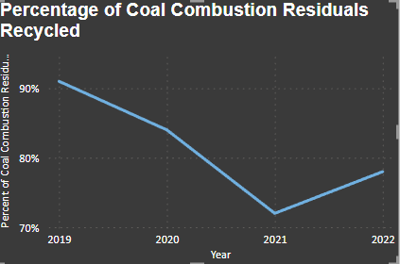

**Figure 2**

The expansion of transmission lines is a direct reflection of CenterPoint Energy's commitment to infrastructural growth and reliability. A consistent increase in the circuit miles of transmission lines from 2019 to 2022 underscores the company's strategic efforts to not only bolster its service delivery to meet demand but also to modernize and enhance its energy transmission backbone. This growth, measured in the extension of circuit miles, indicates a broader vision to cater to future energy needs while maintaining service integrity.

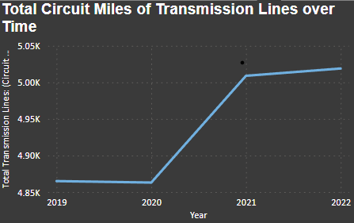

**Figure 3**

The reliability indices for Houston Electric and Indiana Electric present a comparative insight into the company’s operational excellence. Houston Electric's reliability index fluctuated with a notable peak in interruptions in 2021 but saw improvements in the subsequent year. Indiana Electric, conversely, demonstrated a laudable consistency in maintaining lower interruption rates. These indices provide a vital gauge of the operational soundness and resilience of CenterPoint Energy’s distribution networks.

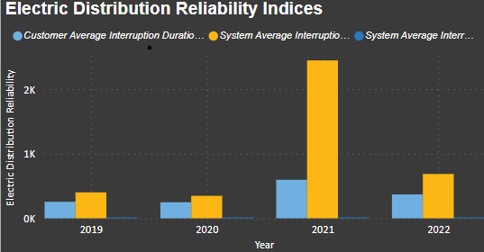

**Figure 4**

An analytical comparison of the growth in distribution lines between Houston Electric and Indiana Electric reveals a strategic allocation of resources and developmental focus. Houston Electric's aggressive expansion could be attributed to increased energy requirements and infrastructural investments, whereas Indiana Electric exhibited a more measured expansion.

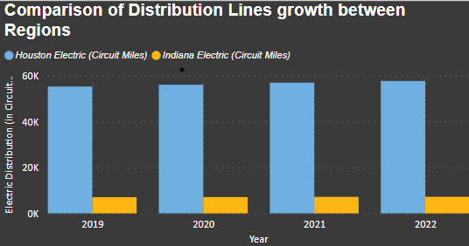

**Figure 5**

**Social Responsibility & Community Contribution Analysis**

To kick off the development of the Community Impact Dashboard, data from the CenterPoint Energy data center was gathered, focusing on employee demographics such as age and gender, new employee hires by gender, workforce composition, and gender distribution among employees. Across all these datasets, a common challenge we faced was the abundance of null values in each table. To streamline our visualizations, we took a critical step in cleaning up the data by replacing these null values with zeros, indicating years where the company has no record in a particular table. Additionally, we found that pivoting the data was beneficial, as it allowed us to restructure certain column headers as rows and rows as columns to enhance clarity and usefulness. Furthermore, we meticulously removed unnecessary columns and rows from each dataset to ensure a focused and precise scope for our data analysis process.

**Figure 10**

Analyzing hiring trends through a donut chart reveals CenterPoint Energy's potential preference for younger talent (25-30-year-olds) from 2019-2022, possibly targeting recent graduates or early-career professionals. This focus on younger talent aligns with a potential strategy to cultivate a fresh perspective and skillset within the organization. Interestingly, no recruitment activity occurred in the oldest age group (71-80) and potentially less in the 61-62 range. This trend warrants further investigation to understand if it reflects a conscious effort to build a younger workforce or limitations on hiring retirees. Regardless, this valuable insight can inform strategic workforce planning by allowing CenterPoint Energy to evaluate its recruitment strategy. They can assess if their current methods effectively attract a diverse talent pool across different age groups. CenterPoint Energy can build a well-balanced workforce equipped to meet the challenges and opportunities of the future.

**Figure 11**

Data analysis reveals a clear imbalance between men and women in different job categories. Craft jobs are mostly filled by males, while administrative roles are dominated by females. This interactive chart allows for a closer look. By drilling down into specific job types, a pattern emerges women significantly outnumber males in service jobs, while the opposite is true for craft jobs. This information is valuable because it can help identify potential bias in hiring practices. If certain jobs have a lot more of one gender than the other, it's worth investigating further to ensure fairness. Understanding the gender makeup of the workforce allows for targeted efforts to promote diversity and inclusion. For example, if there are few women in craft roles, programs could be created to encourage them to pursue these careers.

.

**Figure 12**

A combined line and clustered column chart effectively visualize workforce distribution by full-time and part-time categories across 2019-2022. This format allows stakeholders to see the composition at a glance. Notably, full-time employees consistently make up a larger share, suggesting a focus on stability and core operations. There was a slight overall increase in total employees in 2020 (with modest growth in both categories), followed by a decrease in 2021 and 2022. The line graph tracking total headcount reveals initial workforce growth from 2019 to 2020, followed by a decline. These insights inform strategic decisions around staffing levels, resource allocation, and people management practices to ensure a well-balanced and adaptable workforce for the future.

**Figure 13**

Analysis of hiring trends at CenterPoint Energy from 2019 to 2022, visualized through a pie chart, has more male hires. Notably, in 2019, the proportion of male hires surpassed females. This trend continued throughout 2020 and 2021, resulting in a workforce with a larger male population. Analysis of hiring trends at CenterPoint Energy from 2019 to 2022, visualized through a pie chart, has more male hires. Notably, in 2019, the proportion of male hires surpassed females. This trend continued throughout 2020 and 2021, resulting in a workforce with a larger male population.

Overall, workforce data serves as a cornerstone for informed decision-making within CenterPoint Energy. As this report demonstrates through its analysis of hiring trends, age demographics, gender distribution, and overall workforce composition, valuable insights can be gleaned that inform strategic planning. The observed focus on younger talent in hiring, potential bias in job categories, and fluctuations in full-time employees all highlight areas for further investigation and potential optimization. By leveraging these data-driven insights, CenterPoint Energy can make informed decisions regarding recruitment strategies, talent management practices, and resource allocation. Ultimately, this empowers the organization to build a well-balanced, adaptable workforce equipped to meet the challenges and opportunities of the future.

**Conclusion**

With the use of the Triple Bottom Line analysis strategy, the results show that CenterPoint Energy has been performing well in all the three areas. First, with the financial and operating analysis, it is evident that the company has been making the right moves financially. It has a reliable source of revenue from its products and services with retail gas sales contributing most with 2022 being its highest at $9,321 generated. CenterPoint should continue supporting their retail gas sales to ensure they maintain it as a reliable source of revenue, hopefully maybe even being able to increase it in the future. This seems possible the total number of customers continues to increase from 2020 with a total of 2.8 million in 2023. The same could be said with the consolidated results of operations. With these results, the electric department comes out on top as it consistently operates with a positive income with its highest value in 2021 in which it generated $1,391 million. On the other hand, it is recommended to review the operation of the corporate area as it consistently operates at a loss. Lastly, when looking at where CenterPoint gets its most of its support from shareholders, the top three contributors are, Capitol International Investors, The Vanguard Group, and BlackRock Inc. It is recommended to maintain a good and healthy relationship with these entities as they are a contributor to CenterPoint. It would be a tough blow to the company if they were to be displeased, losing them in the process.

Secondly was the Environmental Stewardship & Sustainability analysis. Over the past couple of years, CenterPoint Energy has seen a steady increase in being environmentally friendly. Since the spike in residues in 2021, the company has greatly decreased its residues which is essential and it shows that the proper measures have been taken to lower residues. Whatever approach was taken must continue to be used. In terms of recycling, the company hit a low in 2021 but since then has seen a subtle increase in 2022. CenterPoint needs to continue in that trajectory to ensure it has a positive impact on the environment as recycling is a major player in environmental sustainability. When it comes to the expansion of transmission lines, CenterPoint has been increasing its coverage since drastically since 2020. The expansion of transmission lines is a direct reflection of CenterPoint Energy's commitment to infrastructural growth and reliability. When looking at the reliability indices from Houston electric and Indiana electric, a comparative insight is offered with Houston electric showing a huge spike in 2021 but with improvements the following year. These indices help understand the resilience of CenterPoint’s distribution networks. The final aspect of this is area is the growth of distribution lines between Houston electric and Indiana electric. Here it can interpret that Houston electric’s could be attributed to increases energy requirements and infrastructure investments.

Lastly was the social responsibility and community contribution aspect. When it comes to the average age of its new hires, CenterPoint Energy's has a potential preference for younger talent (25-30-year-olds). If CenterPoint uses this approach, and is open to diversity, it can build a well-balanced workforce equipped to meet the challenges and opportunities of the future. However, when it comes to the employee's gender, there seems to be an imbalance depending on the job type. If there is any evidence of hiring bias, then it must be addressed to ensure a fair work environment where anyone can be successful based on their own merit. This can be done with programs to encourage people to pursue jobs outside of gender norms. Outside of those who fill the roles, the roles themselves are mostly full-time employees, which make up a larger share, suggesting a focus on stability and core operations.

With the analysis of these three areas, it can be concluded that CenterPoint Energy is in a healthy and stable condition. There are areas that need improvement, all of which were mentioned through the report. If these areas are addressed as recommended, then CenterPoint will be in an even better condition than it currently it.

**Appendix**

**CenterPoint Energy Proxy Statement 2023**

<https://investors.centerpointenergy.com/node/29876/html>

**CenterPoint Energy Proxy Statement 2022**

<https://investors.centerpointenergy.com/node/29096/html>

**CenterPoint Energy Proxy Statement 2021**

<https://investors.centerpointenergy.com/node/27606/html>

**CenterPoint Energy Proxy Statement 2020**

<https://investors.centerpointenergy.com/node/26436/html>

**CenterPoint Energy Form 10-K 2023**

<https://investors.centerpointenergy.com/node/30771/html>

**CenterPoint Energy Form 10-K 2022**

<https://investors.centerpointenergy.com/node/29746/html>

**CenterPoint Energy Form 10-K 2021**

<https://investors.centerpointenergy.com/node/28991/html>

**CenterPoint Energy Form 10-K 2020**

<https://investors.centerpointenergy.com/node/27436/html>

**CenterPoint Energy Environmental Stewardship & Sustainability**

<https://sustainability.centerpointenergy.com/esg-data-center/>

**CenterPoint Energy Social Responsibility & Community Contribution**

<https://sustainability.centerpointenergy.com/esg-data-center/>